INACT - Inclusive and Innovative Pedagogies for Educators

Curriculum: “Differentiated Instruction for Inclusive Classrooms”
Module Name: TOP TEACHER SKILLS FOR DIFFERENTIATED INSTRUCTION
Title of “In Action Part”: Body Language Self Reflection Exercise
Author: Momentum

BODY LANGUAGE SELF REFLECTION EXERCISE
Did you know that language-specific words account for only 10% of communication? The communication process is actually 90% made up of non-verbal information in the forms of tone and body language.

Body language: our mannerisms and demeanour
- facial expressions
- gaze—looking at the other person or away from them; paying attention or not
- gestures—arm and hand movements
- posture—leaning forward or back; relaxed or stiff
- distance from the other person—too close or too far

Tone: the way we speak
- fast or slow
- gentle or aggressive
- with or without pauses

INSTRUCTIONS/QUESTIONS
Have a look at the body language of the educators in these pictures.
Make some notes on their body language.
Is it open, friendly, welcoming, negative?

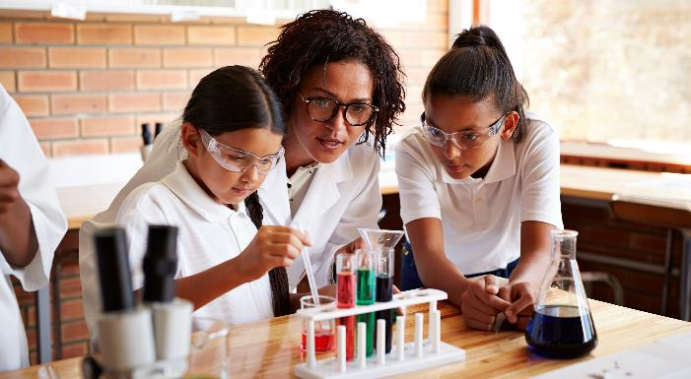

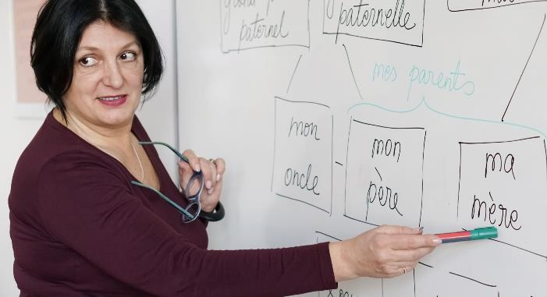
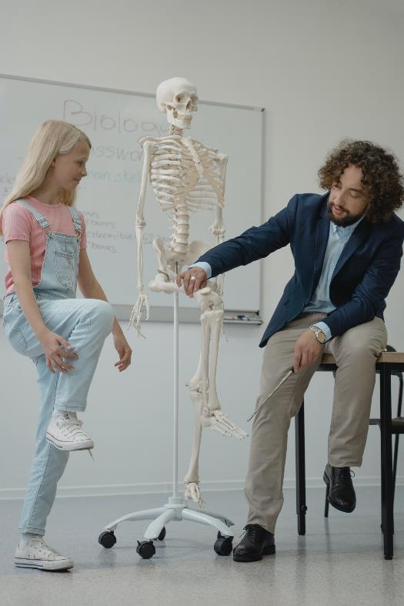

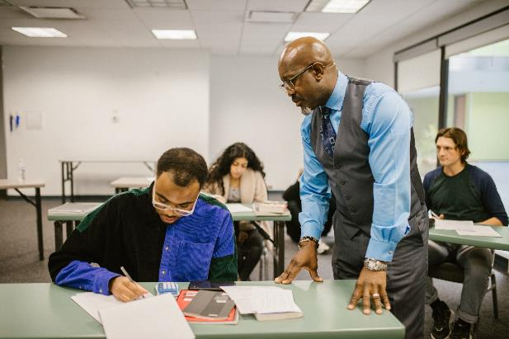
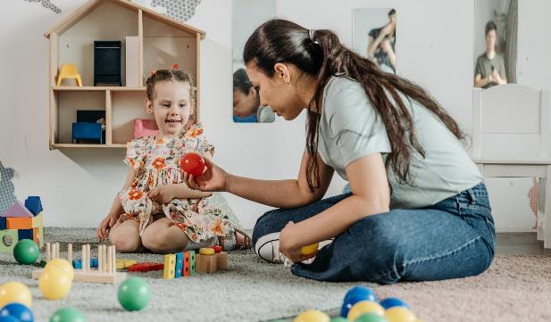
Reflect on your own body language in the classroom, how open, welcoming, inclusive would you say it is.

List the positive body language you currently use/deploy:

List the negative body language you will try to avoid in future:

